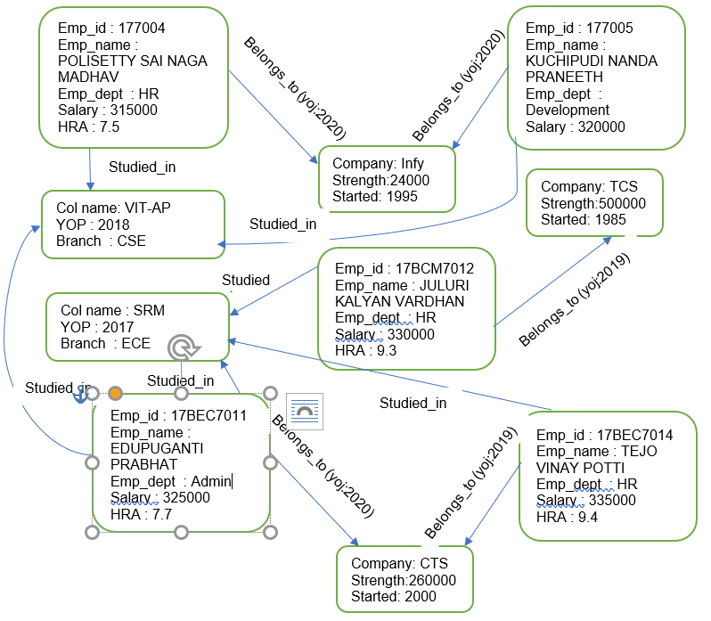

// --- Colleges ---
CREATE (:College {name:'VIT-AP', Col_name:'VIT-AP', YOP:2018, Branch:'CSE'});
CREATE (:College {name:'SRM', Col_name:'SRM', YOP:2017, Branch:'ECE'});

// --- Companies ---
CREATE (:Company {Company:'TCS', Strength:500000, Started:1985});
CREATE (:Company {Company:'Infy', Strength:24000, Started:1995});
CREATE (:Company {Company:'CTS', Strength:260000, Started:2000});

// --- Employees ---
CREATE (:Employee {Emp_id:'177004', Emp_name:'POLISETTY SAI NAGA MADHAV', Emp_dept:'HR', Salary:315000, HRA:7.5});
CREATE (:Employee {Emp_id:'177005', Emp_name:'KUCHIPUDI NANDA PRANEETH', Emp_dept:'Development', Salary:320000});
CREATE (:Employee {Emp_id:'17BCM7012', Emp_name:'JULURI KALYAN VARDHAN', Emp_dept:'HR', Salary:330000, HRA:9.3});
CREATE (:Employee {Emp_id:'17BEC7011', Emp_name:'EDUPUGANTI PRABHAT', Emp_dept:'Admin', Salary:325000, HRA:7.7});
CREATE (:Employee {Emp_id:'17BEC7014', Emp_name:'TEJO VINAY POTTI', Emp_dept:'HR', Salary:335000, HRA:9.4});

// --- STUDIED_IN relationships ---
MATCH (e1:Employee {Emp_id:'177004'}), (c1:College {Col_name:'VIT-AP'})
CREATE (e1)-[:STUDIED_IN]->(c1);

MATCH (e2:Employee {Emp_id:'177005'}), (c2:College {Col_name:'VIT-AP'})
CREATE (e2)-[:STUDIED_IN]->(c2);

MATCH (e3:Employee {Emp_id:'17BCM7012'}), (c3:College {Col_name:'SRM'})
CREATE (e3)-[:STUDIED_IN]->(c3);

MATCH (e4:Employee {Emp_id:'17BEC7011'}), (c4:College {Col_name:'SRM'})
CREATE (e4)-[:STUDIED_IN]->(c4);

MATCH (e5:Employee {Emp_id:'17BEC7014'}), (c5:College {Col_name:'SRM'})
CREATE (e5)-[:STUDIED_IN]->(c5);

// --- BELONGS_TO relationships with joining year ---
MATCH (e1:Employee {Emp_id:'177004'}), (co1:Company {Company:'Infy'})
CREATE (e1)-[:BELONGS_TO {yoj:2020}]->(co1);

MATCH (e2:Employee {Emp_id:'177005'}), (co2:Company {Company:'TCS'})
CREATE (e2)-[:BELONGS_TO {yoj:2020}]->(co2);

MATCH (e3:Employee {Emp_id:'17BCM7012'}), (co3:Company {Company:'TCS'})
CREATE (e3)-[:BELONGS_TO {yoj:2019}]->(co3);

MATCH (e4:Employee {Emp_id:'17BEC7011'}), (co4:Company {Company:'CTS'})
CREATE (e4)-[:BELONGS_TO {yoj:2020}]->(co4);

MATCH (e5:Employee {Emp_id:'17BEC7014'}), (co5:Company {Company:'CTS'})
CREATE (e5)-[:BELONGS_TO {yoj:2019}]->(co5);

// Show all nodes
MATCH (n) RETURN n;

// Display all labels
MATCH (n) RETURN DISTINCT labels(n);

// Verify relationships
MATCH (a)-[r]->(b)
RETURN a.name AS Employee, type(r) AS Relationship, b.name AS ConnectedTo, r.yoj;

